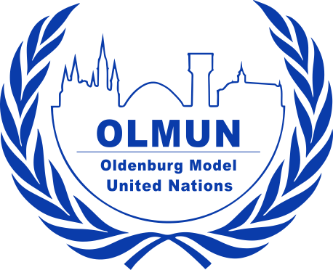
Chair Application Form OLMUN 2026
16th June – 19th June 2026
www.olmun.org
To apply for a chair position at OLMUN 2026, please complete this form and
send it to president@olmun.org by the following deadlines:
Thubelihle Kimberly Nyoni
President of the General Assembly
Beethovenstraße 30a
26180 Rastede
Germany
+49 1521 6395073
president@olmun.org
- 9th of December 2025 (11:59 pm) if you are a member of the OLMUN e.V. (internal application/IC members),
- 19th of December 2025 (11:59 pm) if you are not a member of OLMUN e.V. (external application).
If you are an external applicant (non-IC members), please ask a referee (your MUN-Director or any other eligible referee) for a signed Letter of Recommendation to submit to president@olmun.org by the 10th of December 2025. The letter can be submitted either by the applicant or the referee.
The interviews will be held on the 13th / 14th of December (face-to-face or via video conference for internal applicants) and on the 22nd /27th/28th (for external applicants via video conference

Name: | School/University:
Gender: | Field of study:
Date of Birth: | Grade/Semester:
Nationality: | Mobile:
Graduation: | Home address:
Last English | E-mail:
mark/course:

Do you have any English Language Certificates or other considerable qualifications concerning your English language abilities (such as a stay abroad)?

Do you have experience with applications such as PowerPoint, Excel or Word and formatting documents?

Please state your MUN experience:
Date (Month/Year) | Conference | Position / Committee
Which of the committees available at OLMUN 2026 (see below) would you like to chair?

Please give reasons for your choice.

The following committees are available at OLMUN 2026:
First Committee of the United Nations General Assembly (GA1st)
Third Committee of the United Nations General Assembly (GA 3rd)
African Union (AU)
Association of Southeast Asian Nations + 6 (ASEAN + 6)
Committee on the Rights of the Child (CRC)
European Council (EUC)
International Criminal Court (ICC)
North Atlantic Council (NAC)
United Nations Environment Program (UNEP)
UN Entity for Gender Equality and the Empowerment of Women (UN Women)
United Nations Economic and Social Council (ECOSOC)
United Nations Educational, Scientific and Cultural Organization (UNESCO)
United Nations World Health Assembly (WHA)
United Nations Historical Security Council (UNHSC)
United Nations Security Council (UNSC)

(For detailed information on the committees visit olmun.org. For information about the topics please look at the Agenda OLMUN 2026)

In order to assess your suitability for a chair position at OLMUN 2026, we would like you to answer a few questions. There is neither a minimum nor a maximum length for these answers.

1. What do you think qualifies you for an OLMUN chair position?

2. If selected, what lasting impact do you hope your chairmanship will leave on yourself, the delegates and the conference?

3. In honor of OLMUNs 25th anniversary, what have been your favorite committee topics from previous years and why?

4. What other relevant experiences qualify you for a chair position? Please elaborate

5. Which aspect of chairing do you consider possibly the most challenging, and how do you plan to meet that challenge?

6. What is your most controversial MUN opinion? We want hot takes!!

In case of any concerns or questions, please do not hesitate to contact us via e-mail (president@olmun.org and deppresident@olmun.org).

