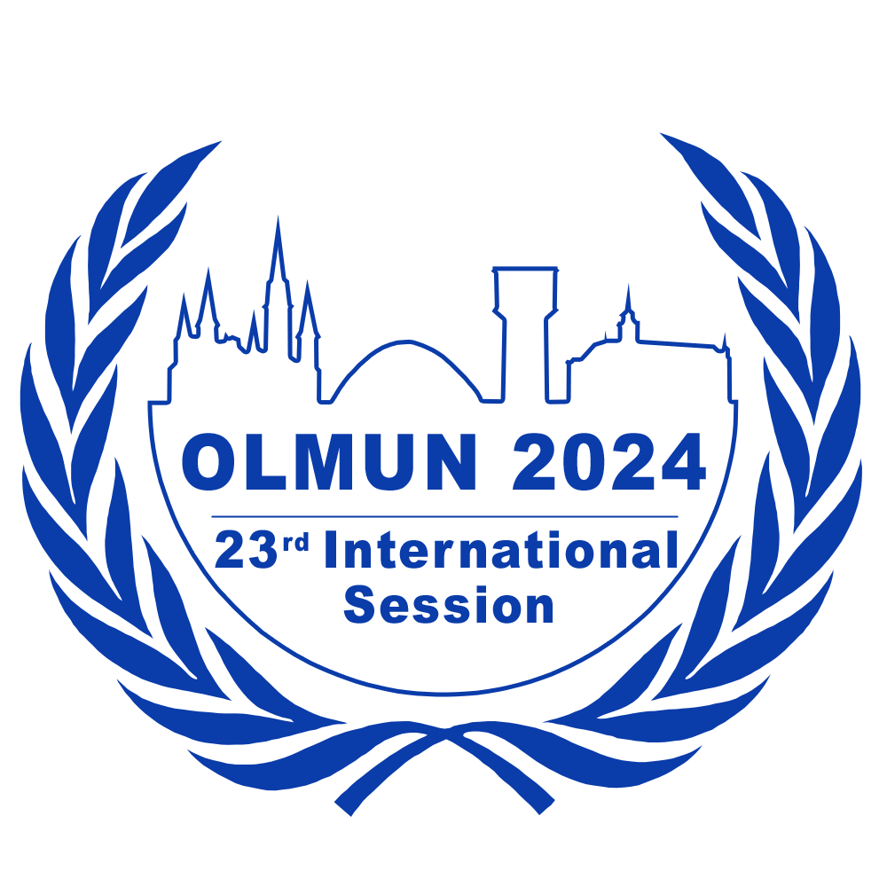
Chair Application Form OLMUN 2024
4th June – 7th June 2024
www.olmun.org
To apply for a chair position at OLMUN 2024, please complete this form and
send it to president@olmun.org by the following deadlines:
Lenja Hinrichs
President of the General Assembly
Ziegelhofstraße 76
26121 Oldenburg
Germany
0049 (0) 152 23919083
president@olmun.org
- 7th of December 2023 (11:59 pm) if you are a member of the OLMUN e.V. (internal application),
- 14th of December 2023 (11:59 pm) if you are not a member of OLMUN e.V. (external application).
If you are an external applicant, please ask a referee (your MUN-Director or any other eligible referee) to send a Letter of Recommendation to president@olmun.org by the 14th of December 2023.
The interviews will be held on the 10th (face-to-face for internal applicants) and the 16th (via video conference for external applicants) of December.

Name: | School/University:
Gender: | Field of study:
Date of Birth: | Grade/Semester:
Nationality: | Phone:
Graduation: | Mobile:
Last English | Home address:
mark/course: | E-mail:
Do you have any English Language Certificates or other considerable qualifications concerning your English language abilities (such as a stay abroad)?

Do you have experience with applications such as PowerPoint, Word etc.?

Please state your MUN experience:
Date (Month/Year) | Conference | Position/Committee

Which of the committees available at OLMUN 2024 (see below) would you like to chair?

Please give reasons for your choice.

The following committees are available at OLMUN 2024:
First Committee of the United Nations General Assembly (GA1st)
Third Committee of the United Nations General Assembly (GA 3rd)
United Nations Environment Programme (UNEP)
United Nations Human Rights Council (UNHRC)
UN Entity for Gender Equality and the Empowerment of Women (UN Women)
United Nations Economic and Social Council (ECOSOC)
United Nations Educational, Scientific and Cultural Organization (UNESCO)
UN Committee on the Peaceful Uses of Outer Space (COPUOS)
United Nations World Health Assembly (WHA)
United Nations Security Council (UNSC)

(For detailed information on the committees visit olmun.org. For information about the topics please look at the Agenda OLMUN 2024)

In order to assess your suitability for a chair position at OLMUN 2024, we would like you to answer a few questions. There is neither a minimum nor a maximum length for these answers.

1. What do you think qualifies you for an OLMUN chair position?

2. What is your motivation for applying for a chair position and what do you wish to accomplish for yourself through your participation in the OLMUN chair team?

3. How do you think a committee should be chaired?

In case of any concerns or questions, please do not hesitate to contact us via e-mail (president@olmun.org).

